Mobile App UI wireframe example

For Who, For What Project

**REVISION STATUS SHEET**

|  |  |  |  |  |
| --- | --- | --- | --- | --- |
| Revision Number | Effective Date | Description / Summary of Revision | Copy updated by  Initials Date | |
| 00 | 22-Jun-2023 | Initial version | Gabriel Chen | 22-Jun-2023 |
|  |  |  |  |  |
|  |  |  |  |  |
|  |  |  |  |  |
|  |  |  |  |  |
|  |  |  |  |  |
|  |  |  |  |  |
|  |  |  |  |  |
|  |  |  |  |  |
|  |  |  |  |  |
|  |  |  |  |  |
|  |  |  |  |  |
|  |  |  |  |  |
|  |  |  |  |  |

Contents

1. EXECUTIVE SUMMARY 3

1.1. PROJECT BACKGROUND 3

1.2. OBJECTIVE 3

1.3. APPROACH 3

2. EXPECTED INPUT FROM CUSTOMER 4

2.1. Design tool and file format 4

2.2. UI designs usually start with small screens and then scale up for the bigger ones 4

3. EXAMPLES 4

4. EXAMPLE 1 4

4.1. Overview and flows 4

4.2. Log in page 5

4.3. Other pages … 5

5. EXAMPLE 2 6

5.1. Overview and flows 6

5.2. Page 1 6

5.3. Other pages … 6

6. EXAMPLE 3 7

6.1. Overview and flows 7

6.2. Page 1 7

6.3. Other pages … 7

7. REMARKS (IF ANY) 8

7.1. Remark 1 8

7.2. Remark 2 8

7.3. Remark 3 8

# EXECUTIVE SUMMARY

## Project background

(Why this project starts, who are the parties involved)

## Objective

* + 1. The objective of this document is to provide the example of Mobile App UI wireframe as a guideline for Mobile App development.

## Approach

* + 1. This document serves as a template for customers to provide the necessary input information to LITEON;
    2. The file format of UI design is not restricted as long as it includes adequate wireframes, App reactions, and other relevant information.

# EXPECTED INPUT FROM CUSTOMER

## Design tool and file format

* + 1. It is recommended to use popular design tools like [Figma](https://www.figma.com/) for designing purposes. Figma provides two file extensions, such as ".fig" for Figma design and ".jam" for FigJam. This platform allows exporting designs directly to PDF format as well;
    2. In addition to Figma, [Zeplin](https://zeplin.io/) is also a popular option for design purposes;

## UI designs usually start with small screens and then scale up for the bigger ones

# EXAMPLES

It will be better if can add more explanation or flow control on the links to indicate the relationship between "condition or operation (onclick, swiping from left to right)" and "page to be shown or actions to be performed".

**Contents below this line are examples for illustration purpose.**

# EXAMPLE 1

## Overview and flows

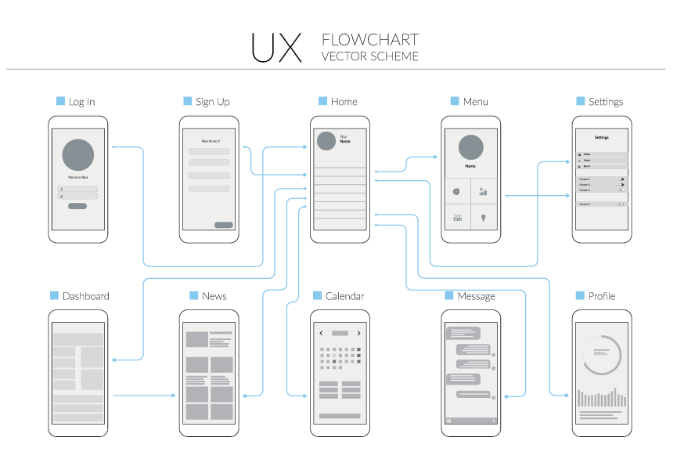

## Log in page

* + 1. Design : <link to the log in UI design, the design should indicate the elements of this page. Such as company logo as background, text input fields, buttons, hyperlinks and fixed strings>
    2. Clicks [Log in] button triggers account validation.
       1. If passed navigates to Home page;
       2. If failed, clean password and prompt to re-enter password;
       3. After 3 unsuccessful log in attempts, pop up “Please contact Administrator at <phone number> for further assistance”;
    3. Clicks “Not a user? Sign up now!” link below [Log in] button navigates to Sign up page;

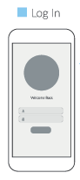

## Other pages …

# EXAMPLE 2

## Overview and flows

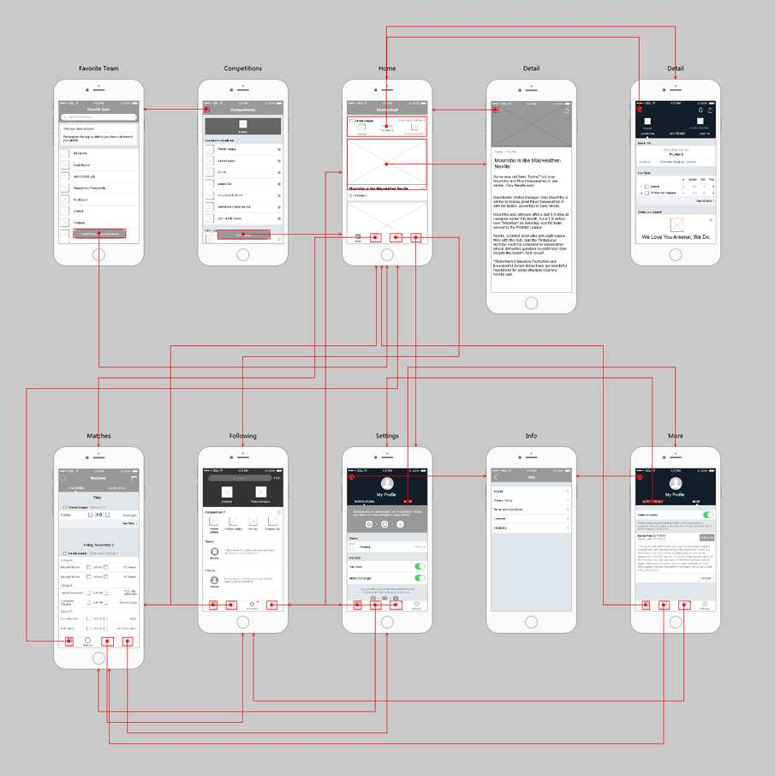

## Page 1

* + 1. Design : <link to the page 1 design, the design should indicate the elements of this page. Such as company logo as background, text input fields, buttons, hyperlinks and fixed strings>
    2. Further explanations;

## Other pages …

* + 1. Design : <link to the page 1 design, the design should indicate the elements of this page. Such as company logo as background, text input fields, buttons, hyperlinks and fixed strings>
    2. Further explanations;

# EXAMPLE 3

## Overview and flows

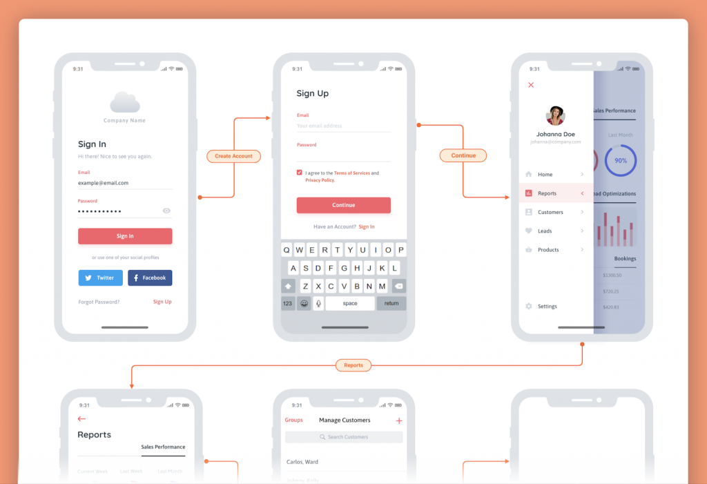

## Page 1

* + 1. Design : <link to the page 1 design, the design should indicate the elements of this page. Such as company logo as background, text input fields, buttons, hyperlinks and fixed strings>
    2. Further explanations;

## Other pages …

* + 1. Design : <link to the page 1 design, the design should indicate the elements of this page. Such as company logo as background, text input fields, buttons, hyperlinks and fixed strings>
    2. Further explanations;

# REMARKS (IF ANY)

## Remark 1

(content)

## Remark 2

(content)

## Remark 3

(content)